Assignment Report

Group Members:

|  |  |
| --- | --- |
| Students ID | Names |
| 814994 | Amrit Singh |
| 815290 | Karamveer Kaur |
| 815203 | Saanch |

Objective:

The objective of this assignment is to create a Python program that allows users to input the name of a fruit to get the number of calories of a particular fruit.

Program Overview:

The data of the fruit report was inserted by a dictionary named fruit_dictionary. The names of the fruits were considered as the keys and the calories as the values. The user is prompted to input the name of a fruit continuously unless Exit is entered by the user. The program then checks if the entered fruit name exists in the dictionary. If it does, the program displays the corresponding calorie count. If the user inputs 'exit', the program terminates. Otherwise, program will ignore the invalid input.

Code Implementation:

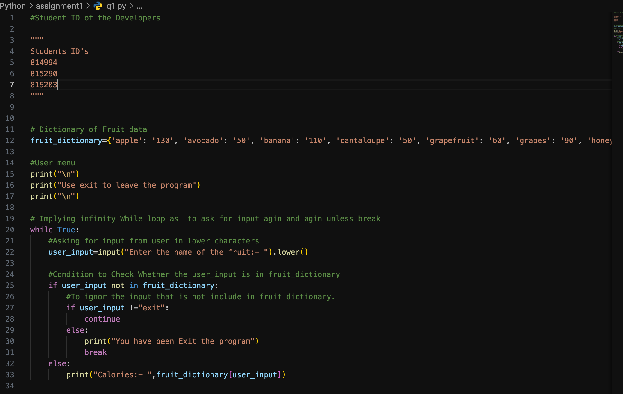

Output:

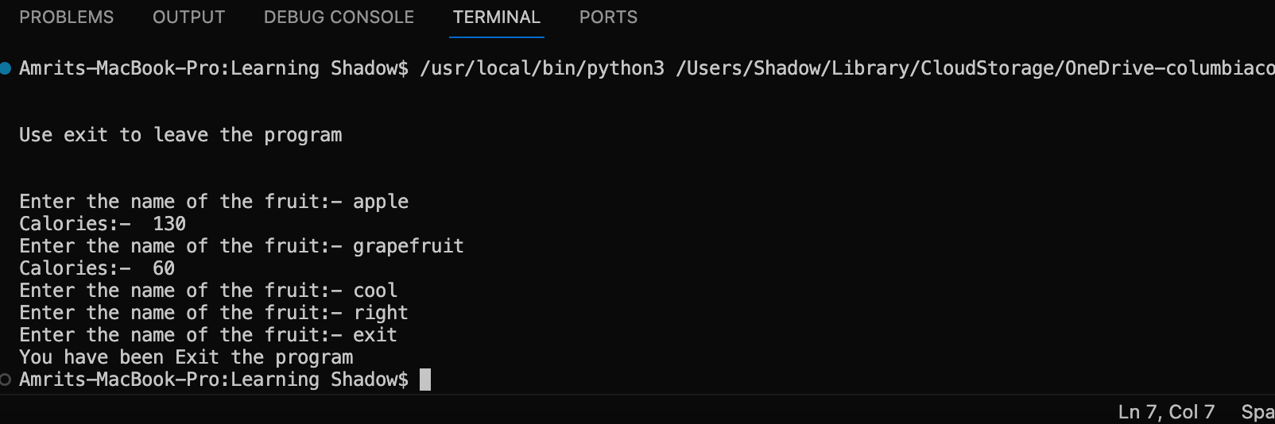

Conclusion:

The program effectively fulfills the requirements by allowing users to retrieve calorie information for various fruits stored in the dictionary. It provides a simple and user-friendly interface while maintaining robust functionality.